Assignment 2

Developing a highly available Photo Album website

Computer Science Department *Swinburne University   
Ho Chi Minh city, Vietnam*  
104775085@student.swin.edu.au

Student Name: Tong Duc Tu Tam

Student ID: 104775085

Date of Submission: 13/07/2024

***Abstract*—This document will present all my work in Assignment 2.**

Keywords—Cloud Computing, AWS Services.

Here are links for your reference:

<http://loadbalancerwebserver-893289495.us-east-1.elb.amazonaws.com/photoalbum/album.php>

(Elastic Load Balancer to view album page)

<http://loadbalancerwebserver-893289495.us-east-1.elb.amazonaws.com/photoalbum/photouploader.php>

(Elastic Load Balancer to upload photos)

<http://ec2-34-227-153-76.compute-1.amazonaws.com/phpmyadmin>

(Dev Server instance to manage database)

- Assignment Checklist:

Infrastructure requirements:

1. VPC configured with 2AZs both with public and private subnets. Public and private route

tables route to IGW and NAT, respectively.

1.1 – Create VPC

Figure 1: Created VPC (TTongVPC-ASM2).

1.2 – Create subnets:

Figure 2: Created subnets.

Figure 3: Attach igw to public route table.

Figure 4: Associate NAT gateway to private route table to allow internet to enter private subnets.

2. Security groups created and properly configured

In the inbound rule of the ELB security group, I allowed HTTP traffic from any IPv4, and set outbound rule to forward that traffic to Web Servers security group.

In the inbound rule of the WebServer SG, I allowed HTTP traffic from ELB security group, and set the outbound rule to forward MySQL traffic to DB security group.

In the inbound rule of the DBServerSG, I allowed MySQL traffic from both the WebServerSG and DevServerSG for development purposes.

I didn’t use the NATServerSG since I configured NAT gateway and routes in route table.

The DevServerSG will allow traffic from everywhere for development purposes.

3. NACL correctly configured

Figure 5: PrivateSubnetsNACL inbound rule block ICMP traffic from Dev Instance and allows HTTP traffic.

Figure 6: PrivateSubnetsNACL outbound rule block ICMP traffic from Dev Instance and allows HTTP traffic.

4. IAM roles properly configured

Figure 7: IAM role of WebServer launch template.

Figure 8: IAM role of lambda function.

5. ASG configured and working correctly

Figure 9: Dev Server AMI created.

Figure 10: Auto Scaling Group detail configuration.

Figure 11: Config the auto scaling group with the launch template of Dev Server.

Figure 12: Target tracking scaling policy.

Figure 13: Auto scaling group launch instances into private subnets.

6. ELB configured and working correctly with associated Elastic Public IP address

Figure 14: Create target group for ELB.

Figure 15: Create Elastic Load Balancer in Public Subnets to receive internet.

7. Photos stored in S3 are correctly accessible. S3 bucket policy is correct.

Figure 16: Photos are accessed from the ELB.

Figure 17: Photos could not be accessed publicly.

Figure 18: Bucket policy to allow only S3 connection from ELB.

8. Lambda configured and working correctly

Figure 19: Test case.

Figure 20: Resized object created.

9. RDS configured and working correctly

Figure 21: RDS is managed through Dev Server instance.

Figure 22: Dev Server IP (Elastic).

Functional Requirements:

1. Website accessible via ELB
2. Photos and their meta-data displayed on album.php page.

Figure 23: ELB can access S3 bucket and display photos-metadata.

1. Photos and their meta-data can be uploaded to the S3 bucket and RDS database.

Figure 24: Upload test photo.

Figure 25: Image is uploaded to S3, RDS, and display.

1. Photos are resized by the Lambda function.

Figure 26: Resized image is created.

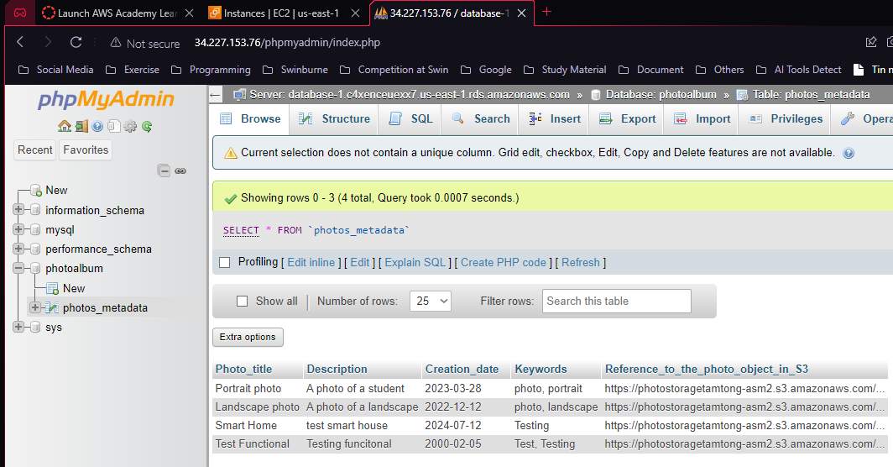

Figure 27: Photo-metadata is automatically recorded in RDS.

Functionality Testing

1. Terminate EC2 instance to see if new instances are replaced.

Figure 28: Terminate instance.

Figure 29: Target group lost 1 instance.

Figure 30: New instance is created.

Figure 31: Functionality of website is preserved.

1. The PhotoAlbum website is accessible through the load balancer only.
2. All EC2 instances are healthy.

1. Direct access to S3 is blocked.

1. Test ICMP ping

When I tried to ping from Dev Server to Web Server in private subnets, it couldn’t ping, even with or without the NACL. I didn’t understand this.